**Q1: How to decomposed time series? And using ARIMA for modeling and forecasting.**

**#Data**

data("AirPassengers")

View(AirPassengers)

AirPassengers

Jan Feb Mar Apr May Jun Jul Aug Sep Oct Nov Dec

1949 112 118 132 129 121 135 148 148 136 119 104 118

1950 115 126 141 135 125 149 170 170 158 133 114 140

1951 145 150 178 163 172 178 199 199 184 162 146 166

1952 171 180 193 181 183 218 230 242 209 191 172 194

1953 196 196 236 235 229 243 264 272 237 211 180 201

1954 204 188 235 227 234 264 302 293 259 229 203 229

1955 242 233 267 269 270 315 364 347 312 274 237 278

1956 284 277 317 313 318 374 413 405 355 306 271 306

1957 315 301 356 348 355 422 465 467 404 347 305 336

1958 340 318 362 348 363 435 491 505 404 359 310 337

1959 360 342 406 396 420 472 548 559 463 407 362 405

1960 417 391 419 461 472 535 622 606 508 461 390 432

**#preparing data**

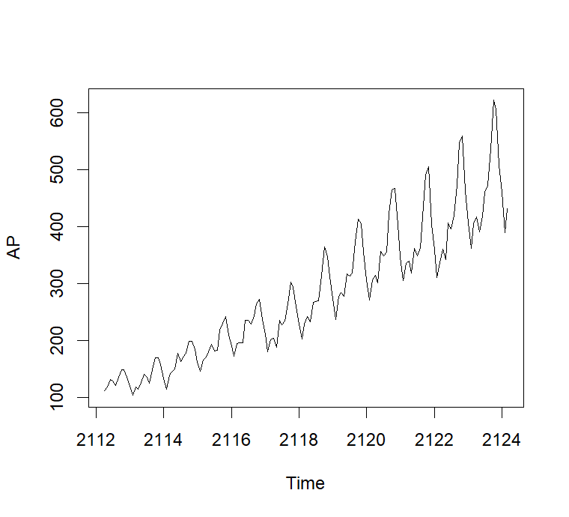AP<-ts(AirPassengers, frequency =12, start =c(1949,1960) )

**# Understanding data**

plot(AP)

**#log-Transform to fix-up variation**

AP2<-log(AP)

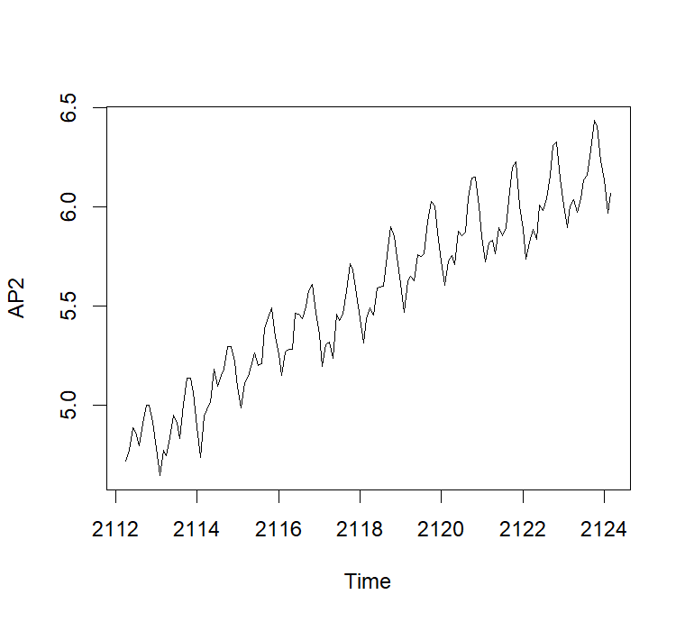plot(AP2)

**#Decompose**

DAP<- decompose(AP2)

DAP$figure

|  |
| --- |
| [1] -0.085815019 -0.114412848 0.018113355 -0.013045611 -0.008966106 0.115392997  [7] 0.210816435 0.204512399 0.064836351 -0.075271265 -0.215845612 -0.100315075 |
|  |
| |  | | --- | |  | |

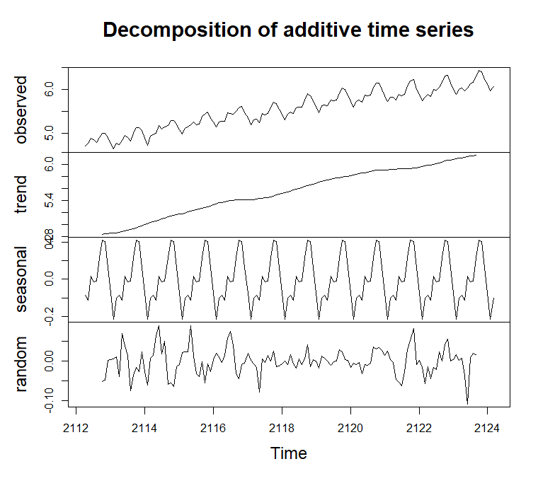plot(DAP$figure,

type = 'b',

xlab = "month",

ylab = "seasonality Index",

colors("red"),

las= 2 )

plot(DAP)

**#Auto rigrative moving average model(ARIMA)**

**#ARIMA(p,d,q) model**

library(forecast)

fitmodel<-auto.arima(AP2)

fitmodel

Series: AP2

ARIMA(0,1,1)(0,1,1)[12]

Coefficients:

ma1 sma1

-0.4018 -0.5569

s.e. 0.0896 0.0731

sigma^2 = 0.001371: log likelihood = 244.7

AIC=-483.4 AICc=-483.21 BIC=-474.77

#**check Residual pot**

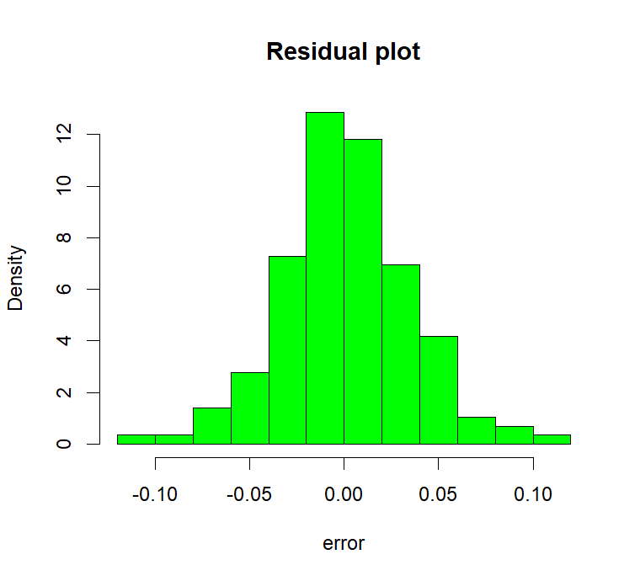

hist(fitmodel$residuals,

main = "Residual plot",

xlab = "error",

col = "green",

freq = F)

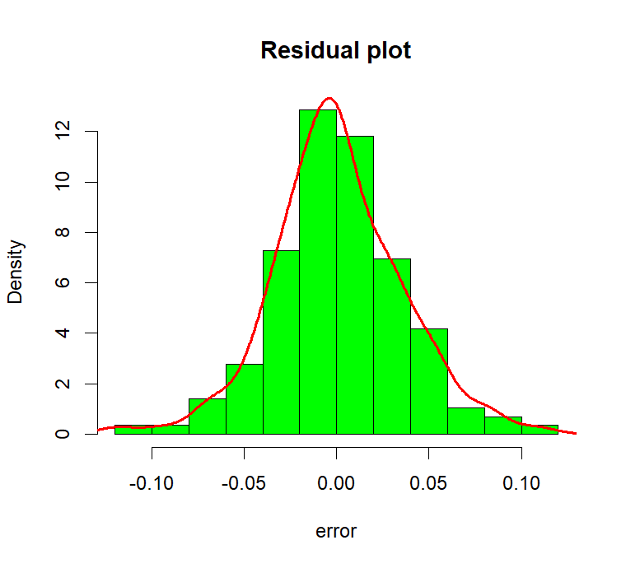lines(density(fitmodel$residuals),

col="red",

lw=2)

**#Forecast for the next 4 years**

pred<-forecast(fitmodel,4*12)

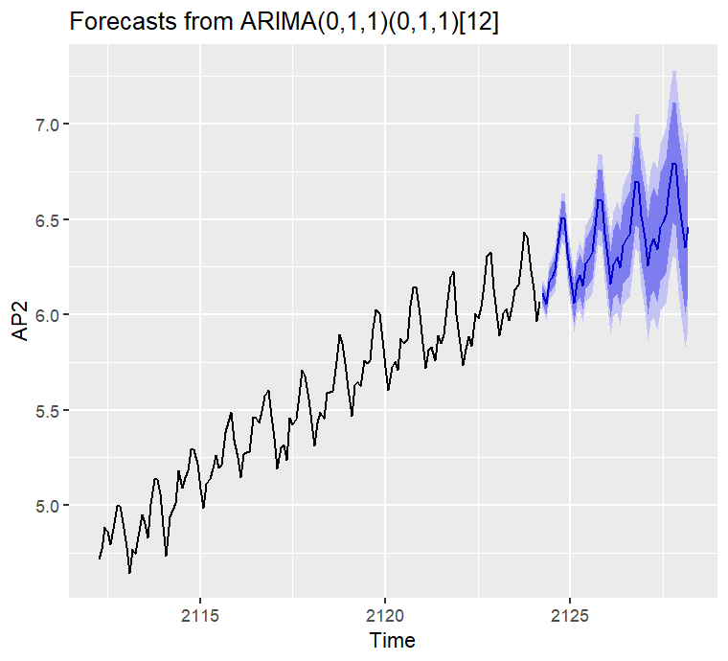library(ggplot2)

autoplot(pred)

accuracy(pred)

ME RMSE MAE MPE MAPE MASE

Training set 0.0005730622 0.03504883 0.02626034 0.01098898 0.4752815 0.216952

2

ACF1

Training set 0.01443892

**Q2: How to select model and using selected model how to forecast by the fitted model?**

**#Data**

data("AirPassengers")

AirPassengers

Jan Feb Mar Apr May Jun Jul Aug Sep Oct Nov Dec

1949 112 118 132 129 121 135 148 148 136 119 104 118

1950 115 126 141 135 125 149 170 170 158 133 114 140

1951 145 150 178 163 172 178 199 199 184 162 146 166

1952 171 180 193 181 183 218 230 242 209 191 172 194

1953 196 196 236 235 229 243 264 272 237 211 180 201

1954 204 188 235 227 234 264 302 293 259 229 203 229

1955 242 233 267 269 270 315 364 347 312 274 237 278

1956 284 277 317 313 318 374 413 405 355 306 271 306

1957 315 301 356 348 355 422 465 467 404 347 305 336

1958 340 318 362 348 363 435 491 505 404 359 310 337

1959 360 342 406 396 420 472 548 559 463 407 362 405

1960 417 391 419 461 472 535 622 606 508 461 390 432

**#understanding and preparing data**

boxplot(AirPassengers-cycle(AirPassengers))

plot(AirPassengers)

abline(lm(AirPassengers-time(AirPassengers)))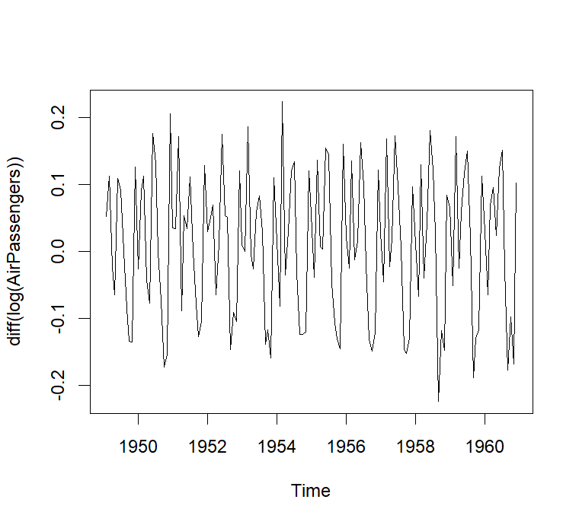

**#make it stationary**

plot(diff(log(AirPassengers)))

**#Modelling: ARIMA(p,d,q)**

library(tseries)

# selecting the value of q

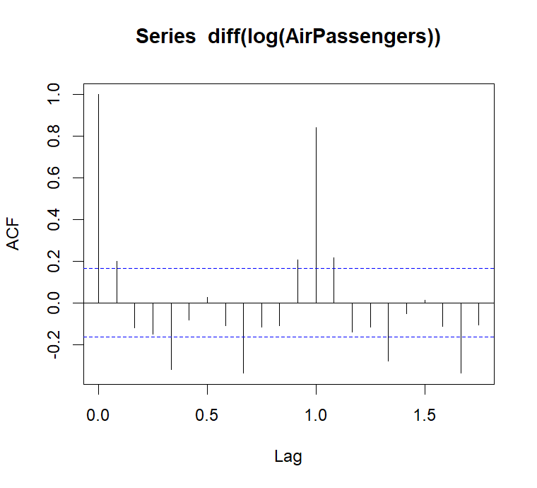acf(AirPassengers)

acf(diff(log(AirPassengers)))

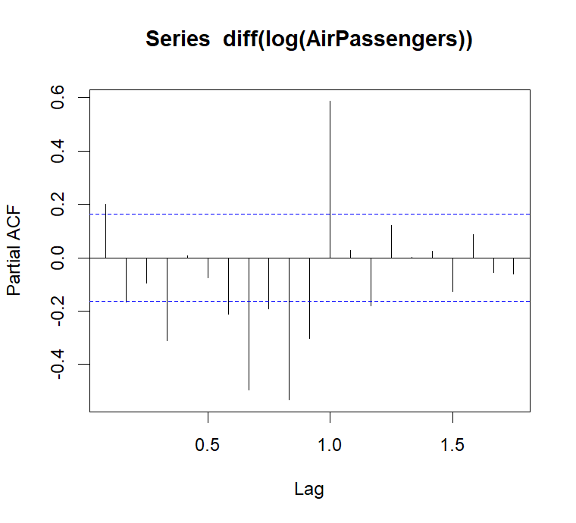**# selecting the value of p**

pacf(diff(log(AirPassengers)))

# fit ARIMA(0,1,1)model

myfit<-arima(log(AirPassengers),

order =c(0,1,1),

seasonal=list(order=c(0,1,1),

period=12))

myfit

Call:

arima(x = log(AirPassengers), order = c(0, 1, 1), seasonal = list(order = c(0,

1, 1), period = 12))

Coefficients:

ma1 sma1

-0.4018 -0.5569

s.e. 0.0896 0.0731

sigma^2 estimated as 0.001348: log likelihood = 244.7, aic = -483.4

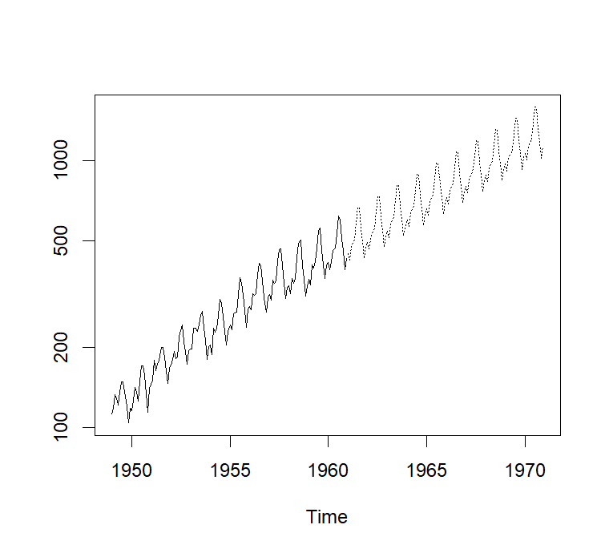

**#forecast for next 10 year**

pred<-predict(myfit,n.ahead = 10*12)

finalpred<-exp(pred$pred)

ts.plot(AirPassengers,finalpred, log='y',lty=c(1,3))

**#cheaking accuracy of the prediction**

datat<-ts(AirPassengers,frequency = 12,start = c(1949,1),end = c(1960,12))

myfit2<-arima(log(datat),

order =c(0,1,1),

seasonal=list(order=c(0,1,1),

period=12))

pred2<-predict(myfit2,n.ahead = 1*12)

finalpred2<-exp(pred2$pred)

finalpred2<-exp(pred2$pred)

pred_1960<-round(finalpred2,0)

true_1960<-tail(AirPassengers,12)

data.frame(pred_1960,true_1960)

pred_1960 true_1960

1 450 417

2 426 391

3 479 419

4 492 461

5 509 472

6 583 535

7 670 622

8 667 606

9 558 508

10 497 461

11 430 390

12 477 432

**Q3: How to time series analysis nicely and fancy style visualisis by using ggplot?**

**# Declaration Library Function**

library(forecast)

library(fpp)

library(fpp2)

library(ggplot2)

**#time series plot**

data(a10)

View(a10)

a10

Jan Feb Mar Apr May Jun Jul Aug

1991 3.526591 3.180891

1992 5.088335 2.814520 2.985811 3.204780 3.127578 3.270523 3.737851 3.558776

1993 6.192068 3.450857 3.772307 3.734303 3.905399 4.049687 4.315566 4.562185

1994 6.731473 3.841278 4.394076 4.075341 4.540645 4.645615 4.752607 5.350605

1995 6.749484 4.216067 4.949349 4.823045 5.194754 5.170787 5.256742 5.855277

1996 8.329452 5.069796 5.262557 5.597126 6.110296 5.689161 6.486849 6.300569

1997 8.524471 5.277918 5.714303 6.214529 6.411929 6.667716 7.050831 6.704919

1998 8.798513 5.918261 6.534493 6.675736 7.064201 7.383381 7.813496 7.431892

1999 10.391416 6.421535 8.062619 7.297739 7.936916 8.165323 8.717420 9.070964

2000 12.511462 7.457199 8.591191 8.474000 9.386803 9.560399 10.834295 10.643751

2001 14.497581 8.049275 10.312891 9.753358 10.850382 9.961719 11.443601 11.659239

2002 16.300269 9.053485 10.002449 10.788750 12.106705 10.954101 12.844566 12.196500

2003 16.828350 9.800215 10.816994 10.654223 12.512323 12.161210 12.998046 12.517276

2004 18.003768 11.938030 12.997900 12.882645 13.943447 13.989472 15.339097 15.370764

2005 20.778723 12.154552 13.402392 14.459239 14.795102 15.705248 15.829550 17.554701

2006 23.486694 12.536987 15.467018 14.233539 17.783058 16.291602 16.980282 18.612189

2007 28.038383 16.763869 19.792754 16.427305 21.000742 20.681002 21.834890 23.930204

2008 29.665356 21.654285 18.264945 23.107677 22.912510 19.431740

Sep Oct Nov Dec

1991 3.252221 3.611003 3.565869 4.306371

1992 3.777202 3.924490 4.386531 5.810549

1993 4.608662 4.667851 5.093841 7.179962

1994 5.204455 5.301651 5.773742 6.204593

1995 5.490729 6.115293 6.088473 7.416598

1996 6.467476 6.828629 6.649078 8.606937

1997 7.250988 7.819733 7.398101 10.096233

1998 8.275117 8.260441 8.596156 10.558939

1999 9.177113 9.251887 9.933136 11.532974

2000 9.908162 11.710041 11.340151 12.079132

2001 10.647060 12.652134 13.674466 12.965735

2002 12.854748 13.542004 13.287640 15.134918

2003 13.268658 14.733622 13.669382 16.503966

2004 16.142005 16.685754 17.636728 18.869325

2005 18.100864 17.496668 19.347265 20.031291

2006 16.623343 21.430241 23.575517 23.334206

2007 22.930357 23.263340 25.250030 25.806090

2008

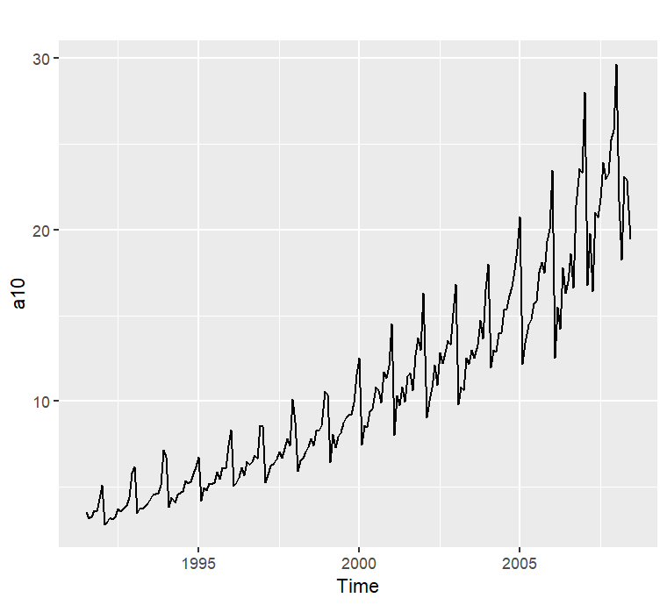

autoplot(a10)+

ggtitle("Antidiabeteic drug sales")+

ylab("$ million")+

xlab("Year")

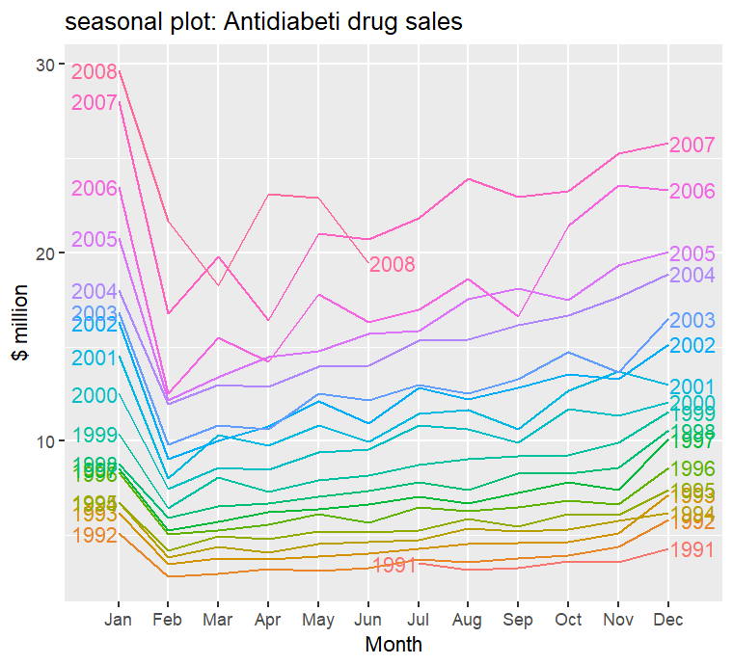**#seasonal plot**

ggseasonplot(a10,year.labels = T,year.labels.left = T)+

ggtitle("seasonal plot: Antidiabeti drug sales")+

ylab("$ million")

**# polar seasonal plot**

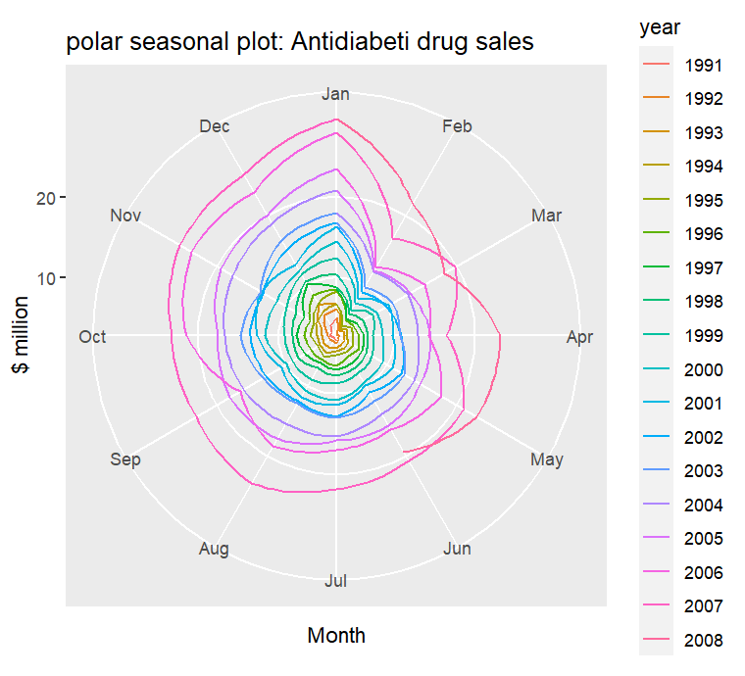

ggseasonplot(a10,polar = T)+

ggtitle("polar seasonal plot: Antidiabeti drug sales")+

ylab("$ million")

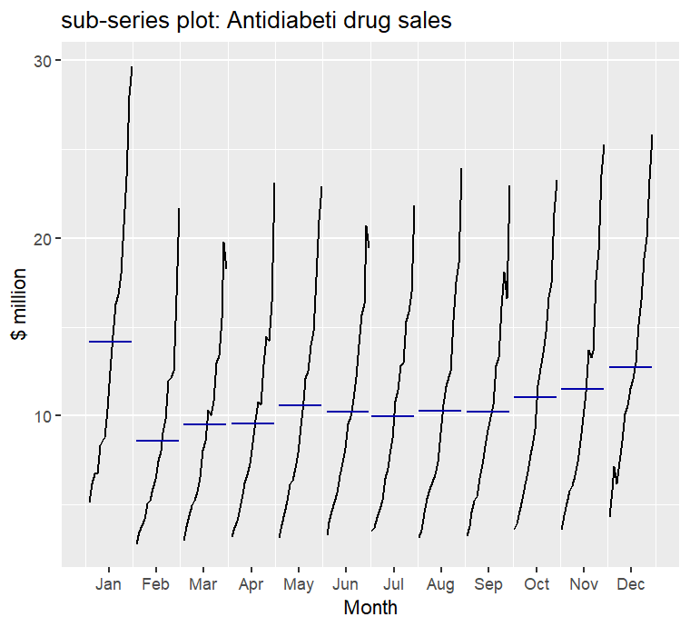**#seasonal sub-series plot**

ggsubseriesplot(a10)+

ggtitle("sub-series plot: Antidiabeti drug sales")+

ylab("$ million")

**# visualizing ausbeer data**

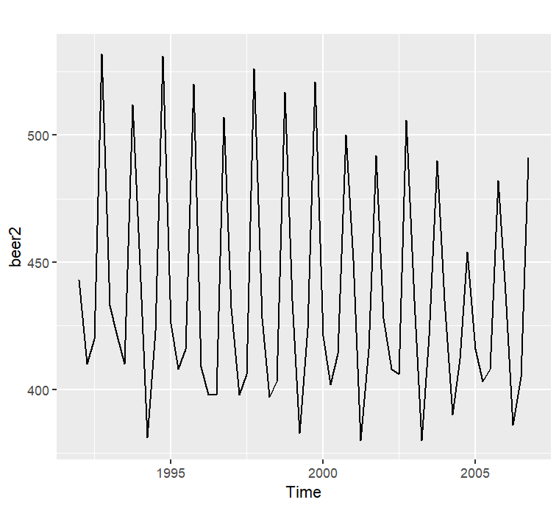data(ausbeer)

beer2<-window(ausbeer,start=1992, end=c(2006,4))

autoplot(beer2)

beerfit1<-meanf(beer2,h=12)

beerfit2<-rwf(beer2,h=12)

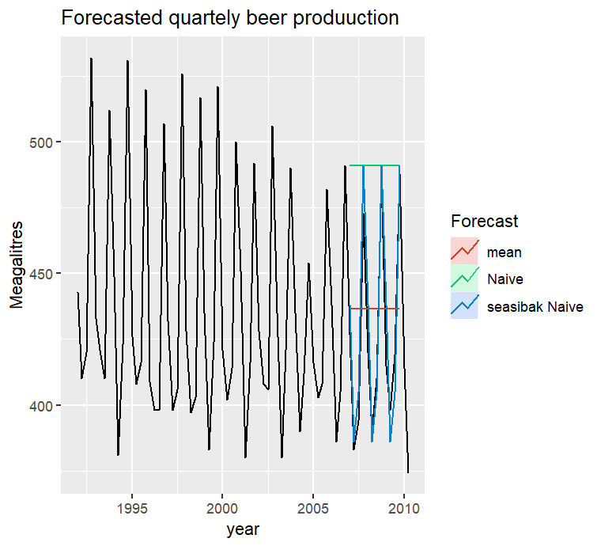beerfit3<-snaive(beer2,h=12)

autoplot(window(ausbeer,start=1992))+

autolayer(beerfit1,series="mean", PI=F)+

autolayer(beerfit2,series="Naive", PI=F)+

autolayer(beerfit3,series="seasibak Naive", PI=F)+

xlab("year")+ ylab("Meagalitres")+

ggtitle("Forecasted quartely beer produuction")+

guides(colour=guide_legend(title = "Forecast"))

**# Accuracy**

beer3<-window(ausbeer,start=2008)

accuracy(beerfit1,beer3)

ME RMSE MAE MPE MAPE MASE ACF1

Training set 1.137019e-14 43.93382 35.64833 -0.9445257 7.954263 2.449456 -0.11987178

Test set -7.950000e+00 36.54726 33.72500 -2.5181562 7.799919 2.317301 -0.07153733

Theil's U

Training set NA

Test set 0.7843278

accuracy(beerfit2,beer3)

ME RMSE MAE MPE MAPE MASE ACF1

Training set 0.8135593 65.91829 55.08475 -0.8600163 12.20968 3.784964 -0.24368919

Test set -62.5000000 71.96353 62.50000 -15.3314577 15.33146 4.294479 -0.07153733

Theil's U

Training set NA

Test set 1.45868

accuracy(beerfit3,beer3)

ME RMSE MAE MPE MAPE MASE ACF1

Training set -1.517857 17.07285 14.55357 -0.4155268 3.372578 1.0000000 -0.3000376

Test set -1.500000 12.51000 10.25000 -0.3069842 2.457364 0.7042945 -0.1108185

Theil's U

Training set NA

Test set 0.2180679

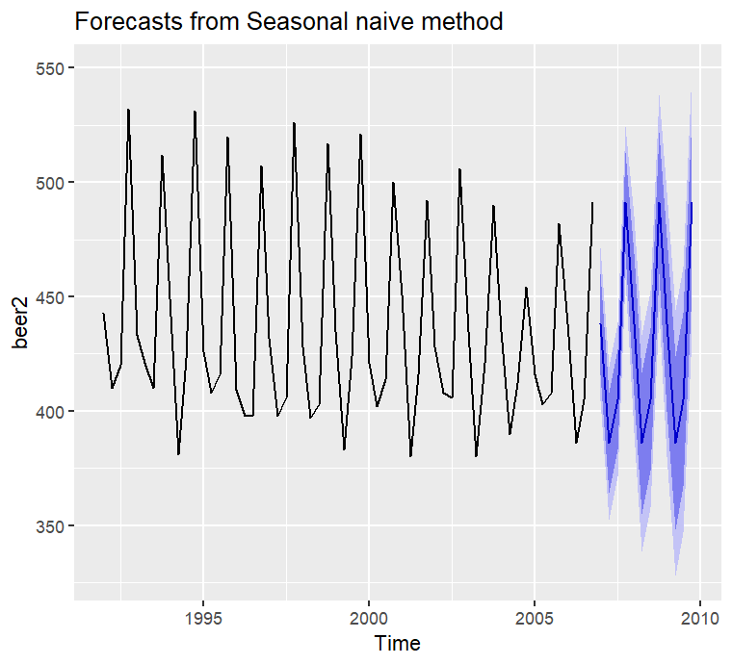**# final selection**

autoplot(beerfit3)

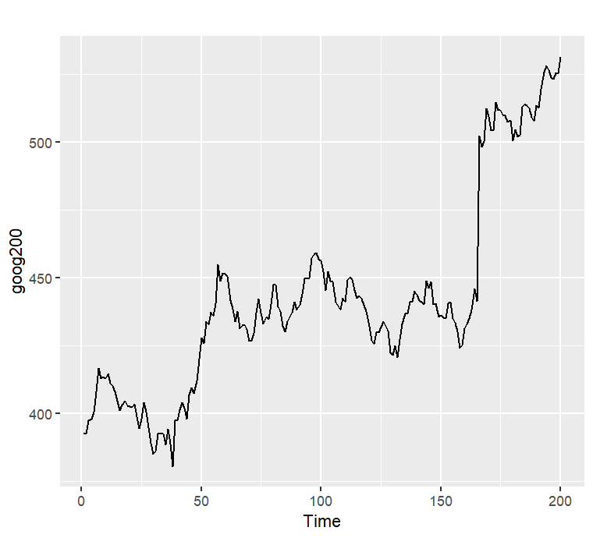**#another data**

goog200

autoplot(goog200)

googf1<-meanf(goog200, h=40)

googf2<-rwf(goog200, h=40)

googf3<-rwf(goog200,drift=T, h=40)

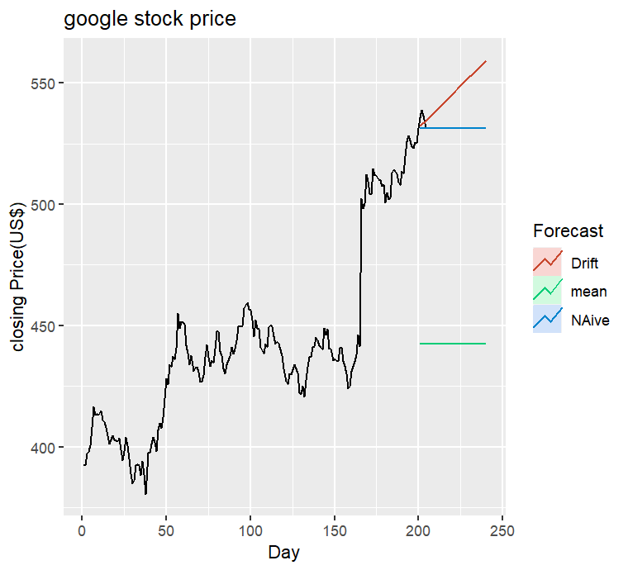autoplot(subset(goog,end=204))+

autolayer(googf1,series="mean",PI=F)+

autolayer(googf2,series="NAive",PI=F)+

autolayer(googf3,series="Drift",PI=F)+

xlab("Day")+ ylab("closing Price(US$)")+

ggtitle("google stock price")+

guides(colour=guide_legend(title = "Forecast"))

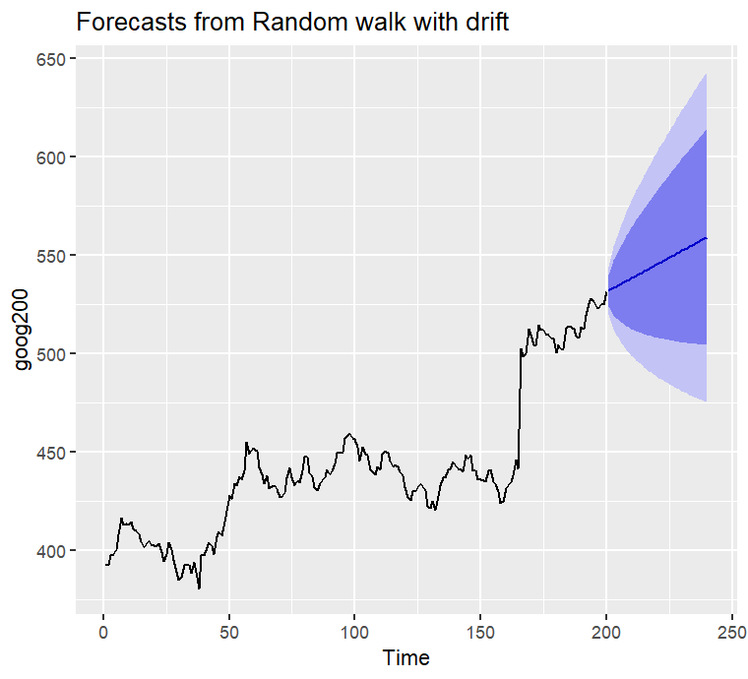

autoplot(googf3)

Q4:

#Time series analysis

#Generating data

x<-rnorm(100)

view(x)

x

[1] -0.747902421 -0.473104847 -1.043941493 0.301811740 -0.768790292 -1.720081168 0.941182594

[8] 0.098858238 -0.172633287 0.005243204 -2.274052694 -0.241189658 -0.963456340 -1.269223866

[15] -0.204649214 -0.578163420 0.792070404 0.994943032 0.570492941 1.985719223 -0.401389408

[22] -1.047643412 1.222313278 -0.262379784 -0.100142898 0.206916475 -0.768081751 1.501641738

[29] 0.376477770 -1.342183435 0.180629301 1.402199601 0.137801130 -0.389898041 0.557685488

[36] -0.178110744 0.615545590 -0.787168830 2.713623354 -0.836511777 0.970026107 0.624321476

[43] -1.470236404 -0.225251506 0.470230281 0.252471030 -0.157419568 -0.292884635 -0.922608559

[50] 0.182791739 0.664990652 0.036177997 0.708713968 0.567625313 0.160513568 -0.253858410

[57] 0.767612825 0.122492916 1.210583084 0.297926273 0.610016130 -0.039471050 -0.227182402

[64] 1.363345872 -1.310373224 -1.098287587 1.546954349 -1.277452050 -1.173382852 -0.424480775

[71] -0.832962303 0.765737671 -1.045133807 0.915634701 1.138473152 -0.777817327 0.732703687

[78] -0.908835893 0.949568183 -0.476987385 -0.562065630 -0.338426928 0.886970819 0.259039398

[85] 1.431263319 -0.883622185 1.422749875 0.779002661 -0.013507713 -0.036438356 0.239295459

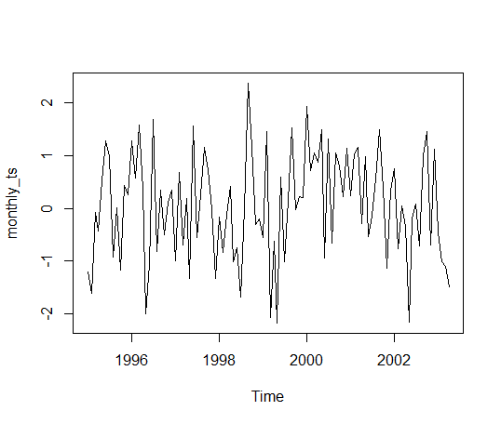monthly_ts<-ts(data = x,start = 1995,frequency = 12)

plot(monthly_ts)

### #Detection of Trend and Get A Stationary Time Series

### install.packages("fpp")

### library(fpp)

### library(forecast)

### data("ausbeer")

### View(ausbeer)

### Ausbeer

### 284 213 227 308 262 228 ………..

### beer.ts<-window(ausbeer,start=1995,end=2005)

### plot(as.ts(beer.ts))

### #Creating Moving Average That Will Be Close To Trend

### beer.trend <- ma(beer.ts,order=4,centre = T)

### #Plot Trend and MA Together

### plot(as.ts(beer.ts))

### lines(beer.trend)

#remove the trend from the time series

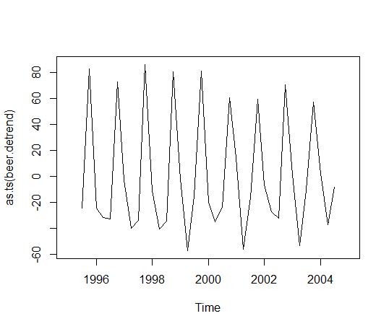beer.detrend=beer.ts-beer.trend

plot(as.ts(beer.detrend))

Y(t)=g(t)+s(t)+h(t)+€(t)

Where

g(t) refers to trends

s(t) refers to seasonality,

h(t) refers to effect of holidays to the forecast

e(t) refers to error term

#Time series analysis

#Getting wikipedia trend data

install.packages("wikipediatrend")

library(wikipediatrend)

data<-wp_trend(page = "Sakib_al_hasan",

from = "2015-01-01",

to="2021-08-20")

View(data)

Language article date views

1 en sakib_al_hasan 2015-01-01 4

2 en sakib_al_hasan 2015-01-02 0

3 en sakib_al_hasan 2015-01-03 5

4 en sakib_al_hasan 2015-01-04 8

5 en sakib_al_hasan 2015-01-05 9

361 en sakib_al_hasan 2015-12-27 0

362 en sakib_al_hasan 2015-12-28 0

363 en sakib_al_hasan 2015-12-29 0

364 en sakib_al_hasan 2015-12-30 0 ……………

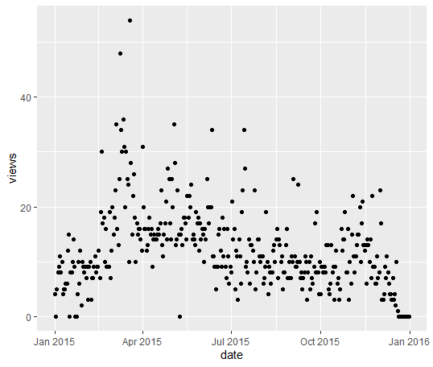#plot

library(ggplot2)

qplot(date,views,data = data)

summary(data)

language article date views

Length:365 Length:365 Min. :2015-01-01 Min. : 0.00

Class :character Class :character 1st Qu.:2015-04-02 1st Qu.: 8.00

Mode :character Mode :character Median :2015-07-02 Median :11.00

Mean :2015-07-02 Mean :12.29

3rd Qu.:2015-10-01 3rd Qu.:16.00

Max. :2015-12-31 Max. :54.00

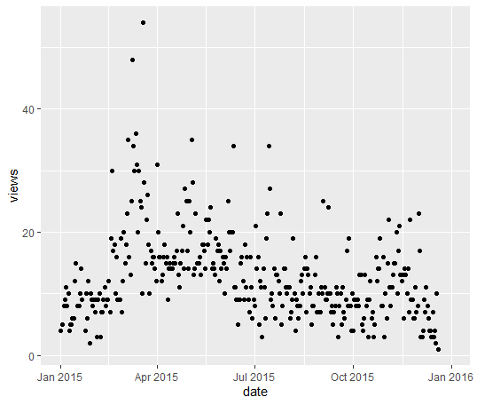#manupulation data

data$views[data$views==0]<-NA

qplot(date,views,data = data

After manipulate data all off zero value used as a missing value with NA in data table and from the plot we seeing that here has no zero value for any single day.

ds<-data$date

y<-log(data$views)

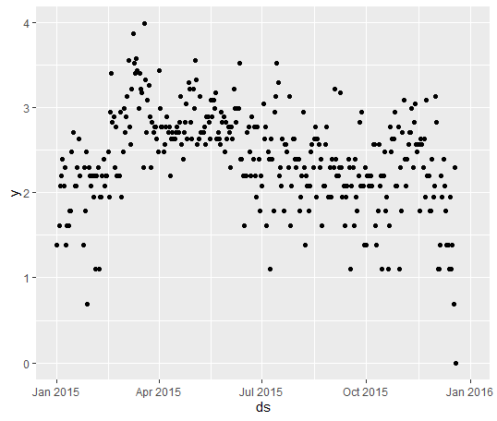df<-data.frame(ds,y)

View(df)

qplot(ds,y,data = df)

ds y

1 2015-01-01 5.476464

2 2015-01-02 NA

3 2015-01-03 4.976734

4 2015-01-04 5.247024

5 2015-01-05 5.451038

6 2015-01-06 6.538140

#forcusting with facebook prphet

install.packages("prophet")

library(prophet)

mf<-prophet(df)

Disabling yearly seasonality. Run prophet with yearly.seasonality=TRUE to override this.

Disabling daily seasonality. Run prophet with daily.seasonality=TRUE to override this.

#prediction

prdict<-make_future_dataframe(mf,365)

tail(predict)

y ds

725 2016-12-25

726 2016-12-26

727 2016-12-27

728 2016-12-28

729 2016-12-29

730 2016-12-30

forecast<-predict(mf,predict)

tail(forecast(c['ds','yhat','yhat_lower','yhat_upper')

Ds Yhat yhat_lower yhat_upper

725 2016-12-25 5.196761 3.872847 6.535854

726 2016-12-26 5.318334 4.010592 6.626629

727 2016-12-27 5.329512 3.951958 6.645157

728 2016-12-28 5.323802 3.996477 6.627882

729 2016-12-29 5.346154 4.030595 6.651266

730 2016-12-30 5.304304 3.959696 6.630339

exp(5.304)

[1] 201.1398

video00

#Time series analysis

#Getting lattest data of Bangladesh

data<-read.csv(choose.files(),header=T,sep=",")

View(data)

#packages

install.packages("ggplot2")

install.packages("dplyr")

library(ggplot2)

library(dplyr)

#screaning Data for analysis

data1<-filter(data,location--"Bangladesh")

View(data1)

data1<-filter(data1,date>="2020-03-15")

data2<-select(data1,date,new_cases)

View(data2)

str(data2)

data2$date<-as.date(data2$date)

#plot

qplot(date,new_cases,data = data2,

main="covid-19 new cases in Bangladesh")

df<-data2$date

y<-data.frame(ds,y)

View(df)

#Forecasting

install.packages("prophet")

library(prophet)

mcc<-prophet(df)

#prediction

predict<-make_future_dataframe(mcc,periods = 130)

forecast<-predict(mcc,predict)

plot(mcc,forecast,xlab="data",ylab="newcases")

#video0005

#Time series analysis

#Getting lattest data of Bangladesh

data<-read.csv(choose.files(),header=T,sep=",")

View(data)

#packages

install.packages("ggplot2")

install.packages("dplyr")

library(ggplot2)

library(dplyr)

#screaning Data for analysis

data1<-filter(data,location--"Bangladesh")

View(data1)

data1<-filter(data1,date>="2020-03-15")

cc<-select(data1,date,total_cases)

View(cc)

str(cc)

cc$total_cases<-as.numeric(cc$total_cases)

cc$date<-as.date(cc$data)

#plot

qplot(date,total_cases,data =cc,)

main="covid-19 confirmed cases in Banglade"

df<-cc $date

y<-data.frame(ds,y)

View(df)

#Forecasting

install.packages("prophet")

library(prophet)

mcc<-prophet(df)

#prediction

predict<-make_future_dataframe(mcc,periods = 180)

tail(predict)

forecast<-predict(mcc,predict)

tail(forecast[c('ds','yhat','yhat_lower','yhat_upper')])

plot(mcc,forecast)

dyplot.prophet(mcc,forecast)

prophet_plot_components(mcc,forecast)

#model 1 performance

pred<-forecast$yhat[1:332]

actual<-mcc$history$y

plot(actul,pred)

abline(lm(pred~actual),col="red"

)